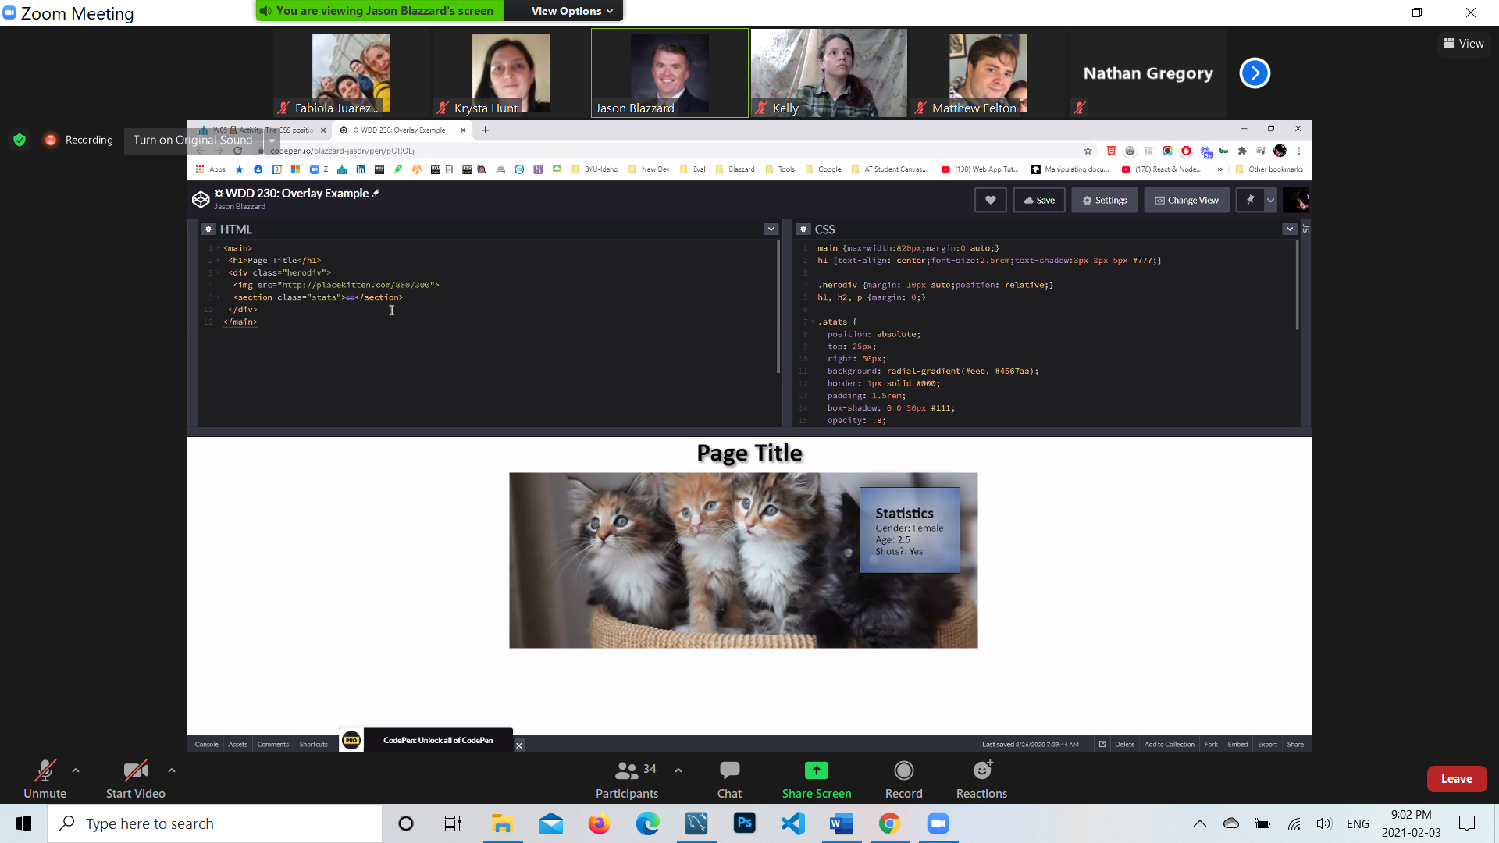

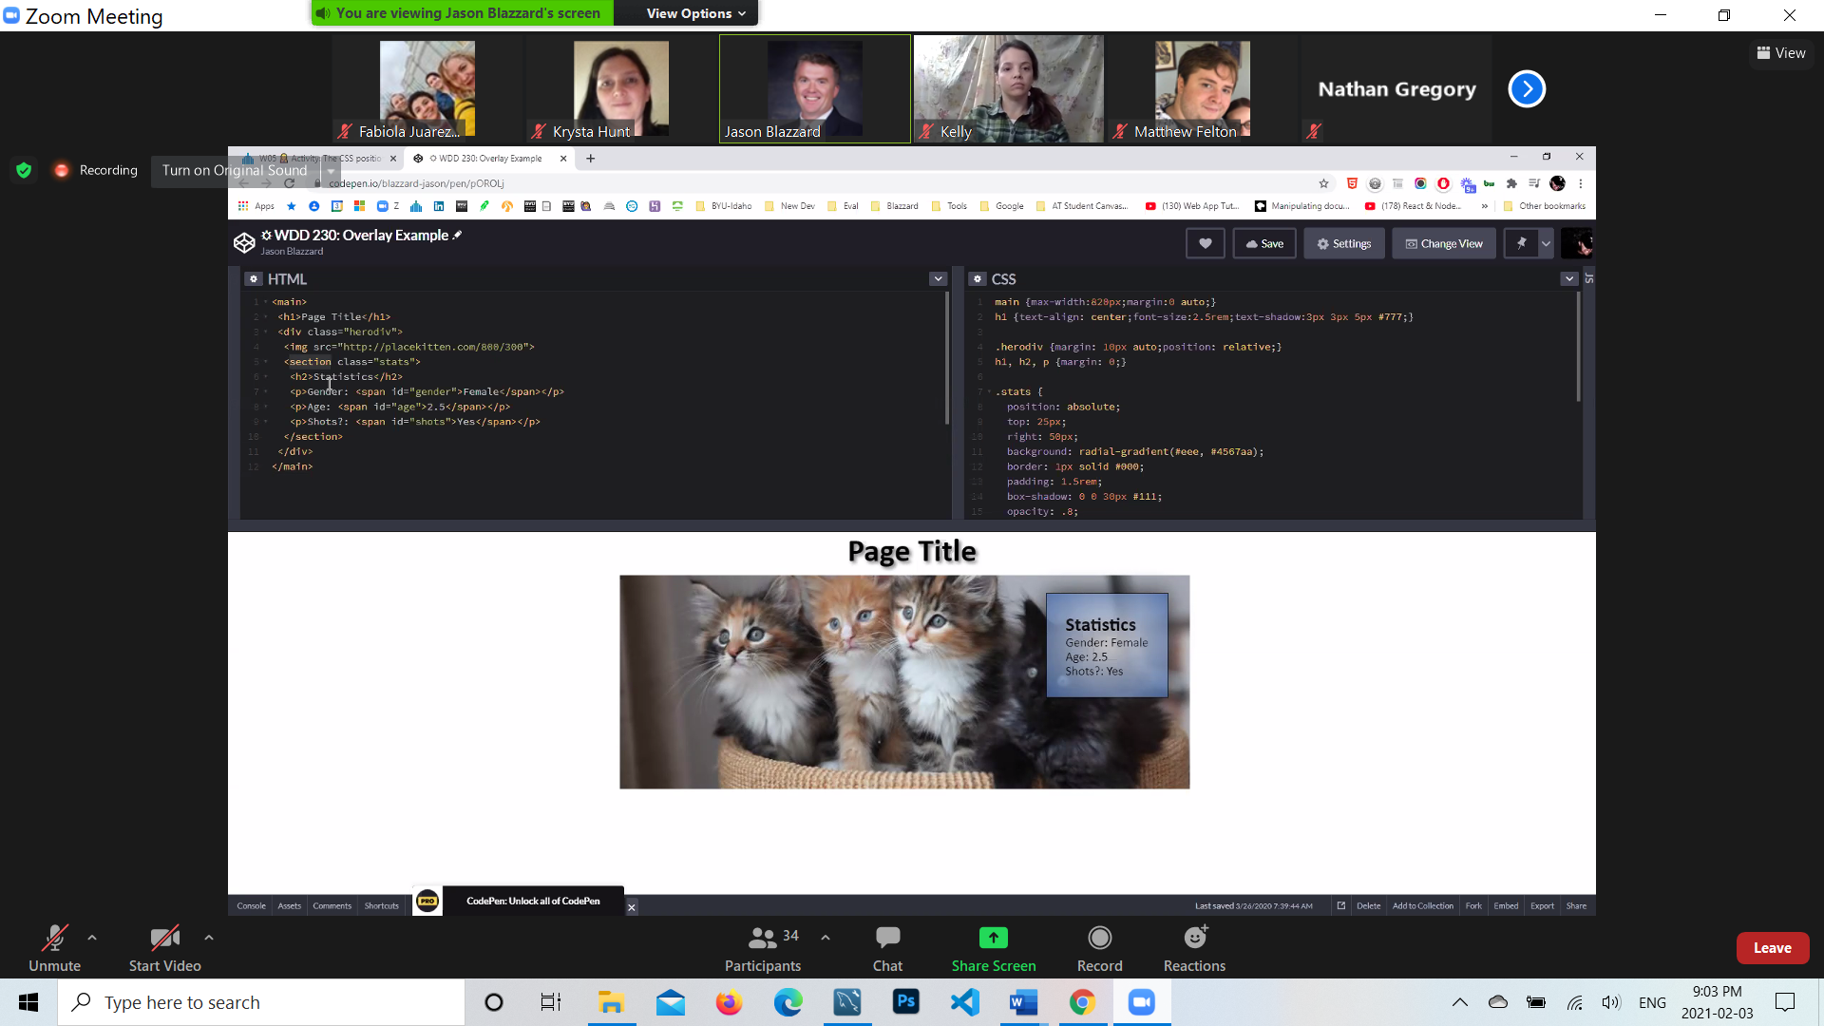

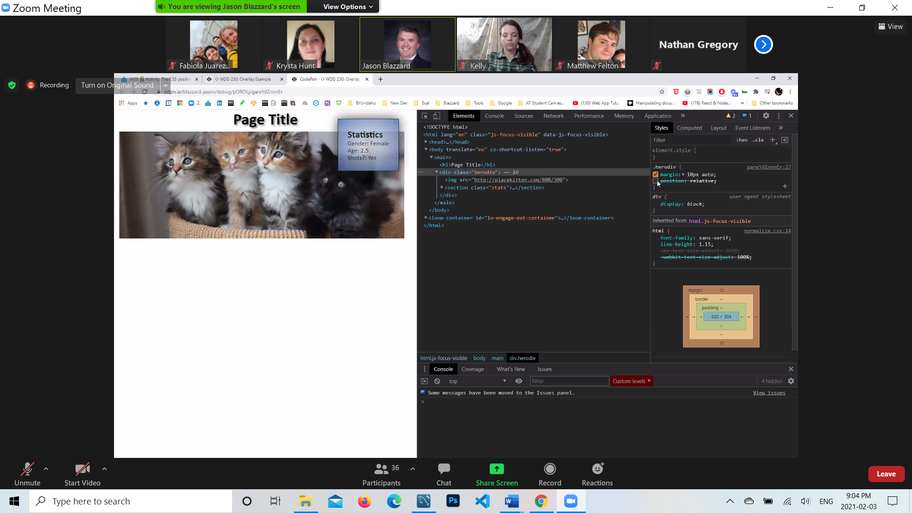



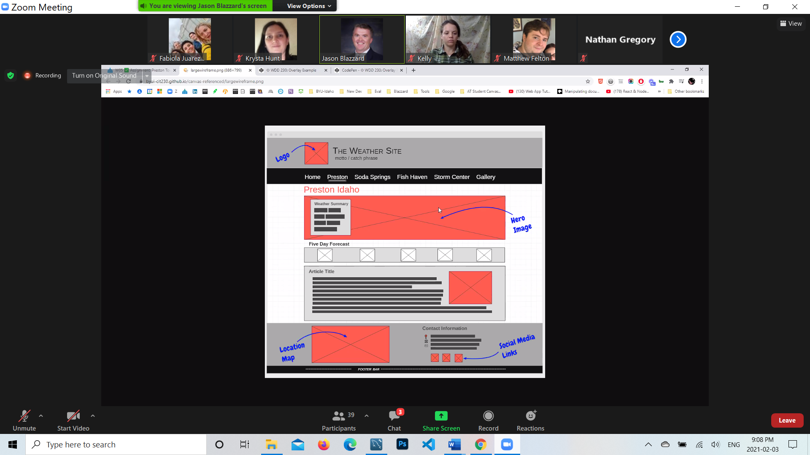

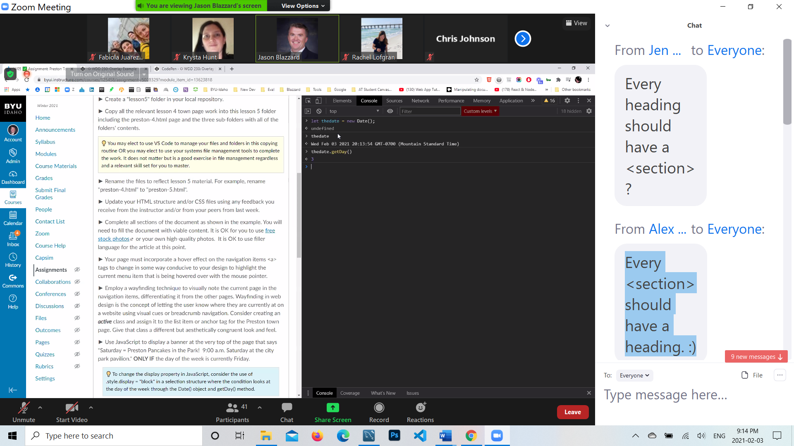

Every <section> should have a heading. :)

(Condition)?a:b;

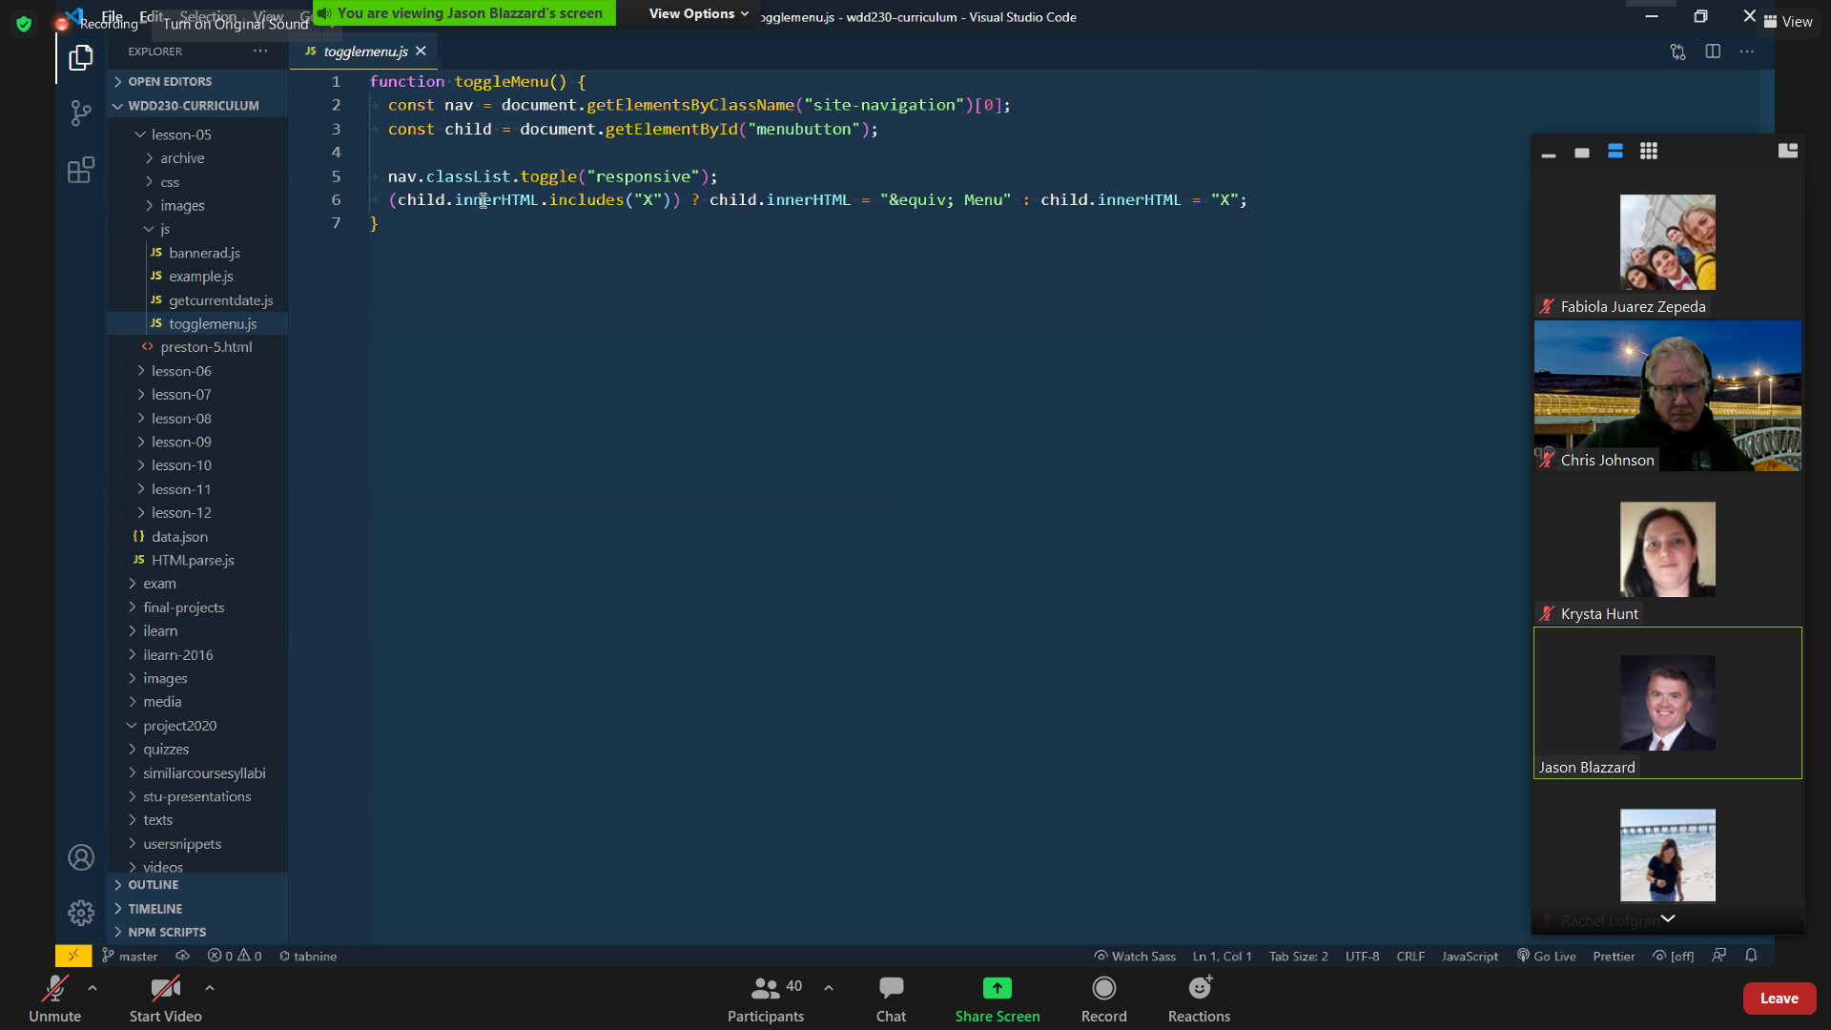

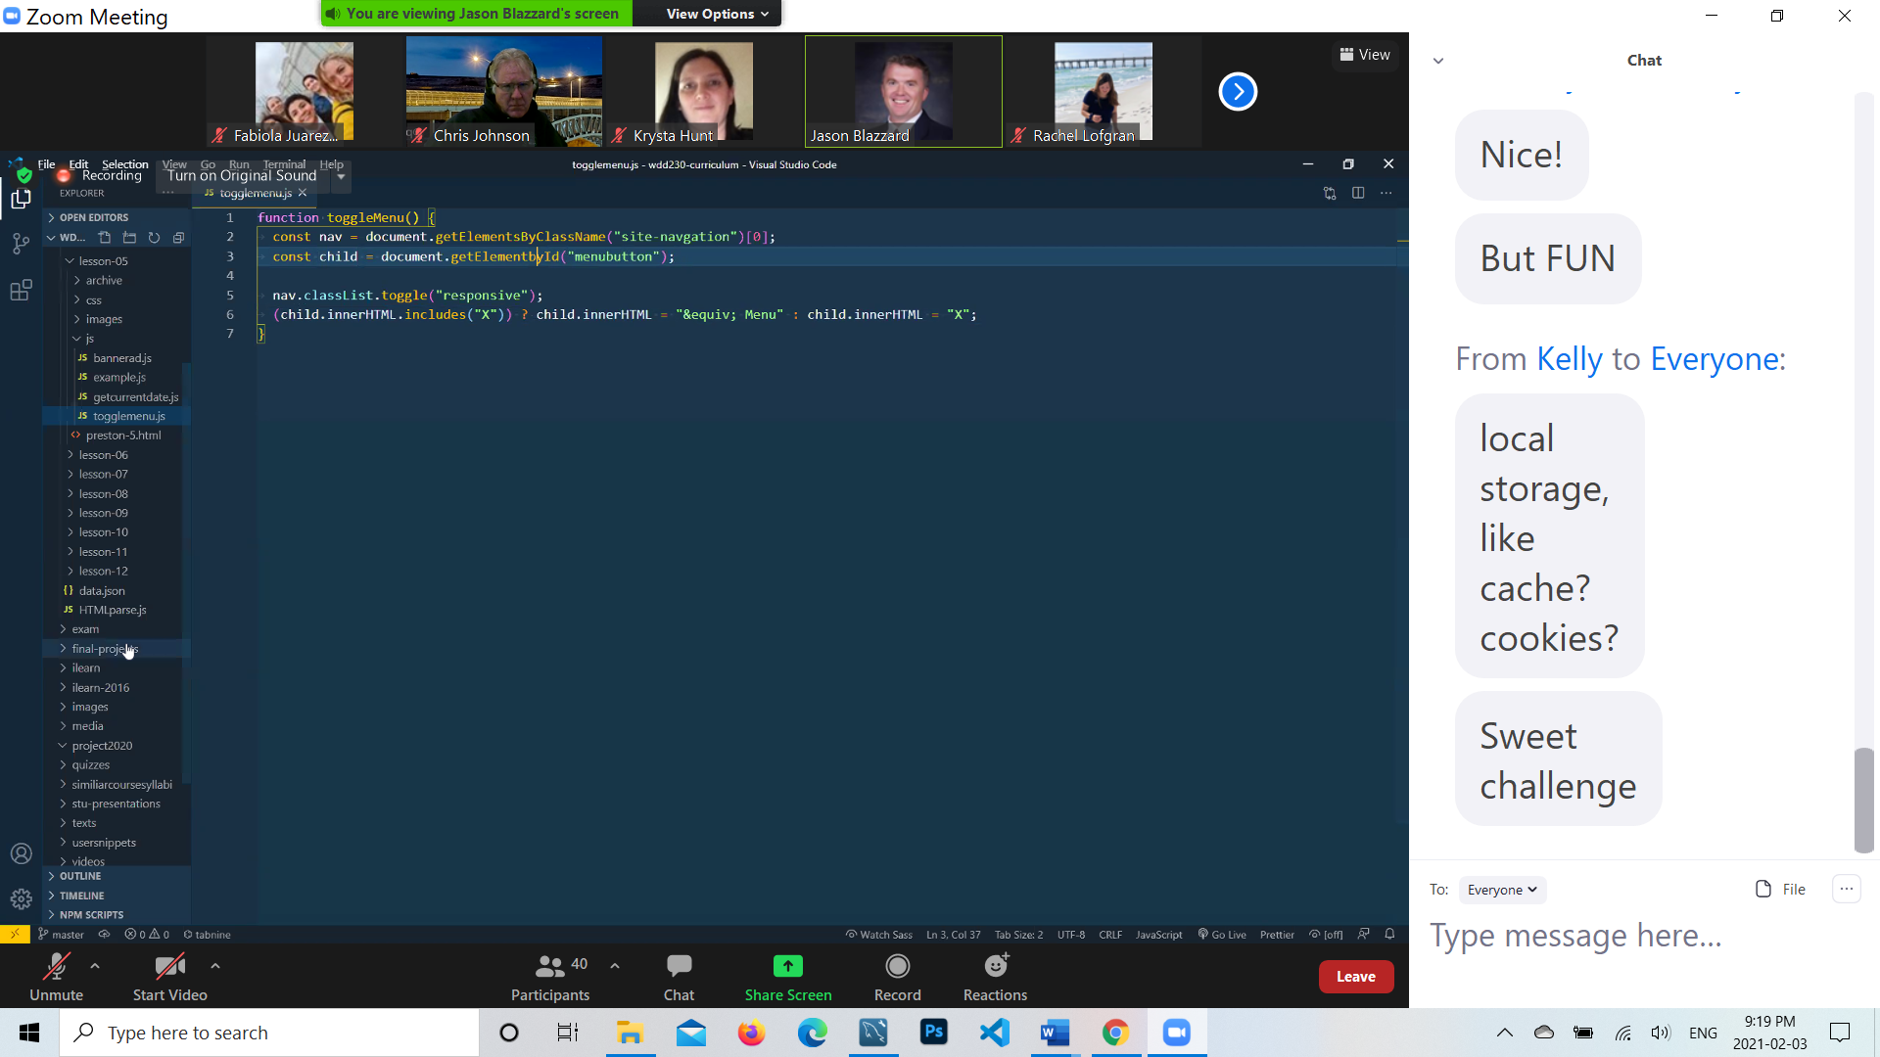

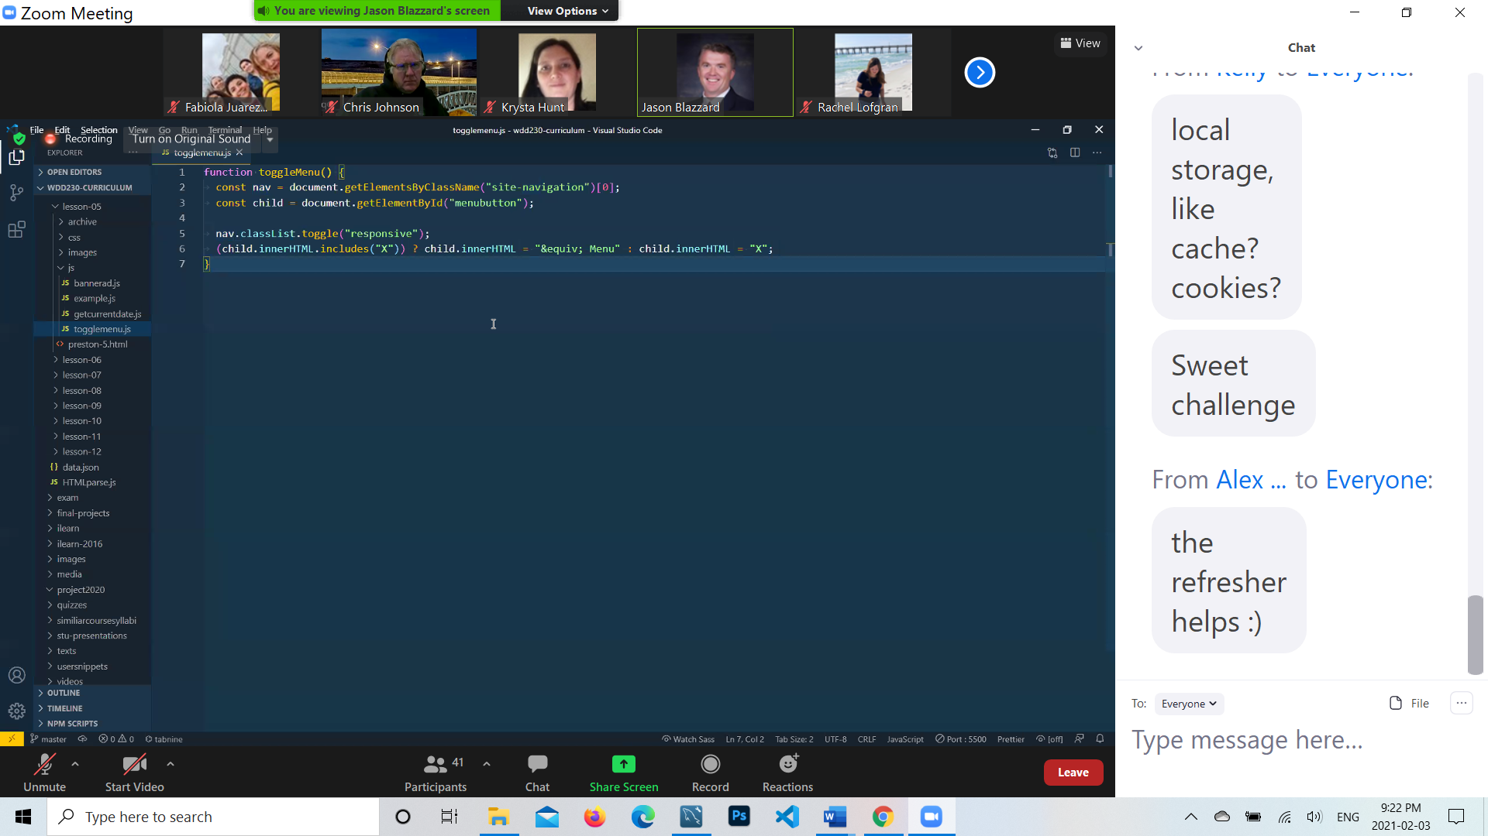

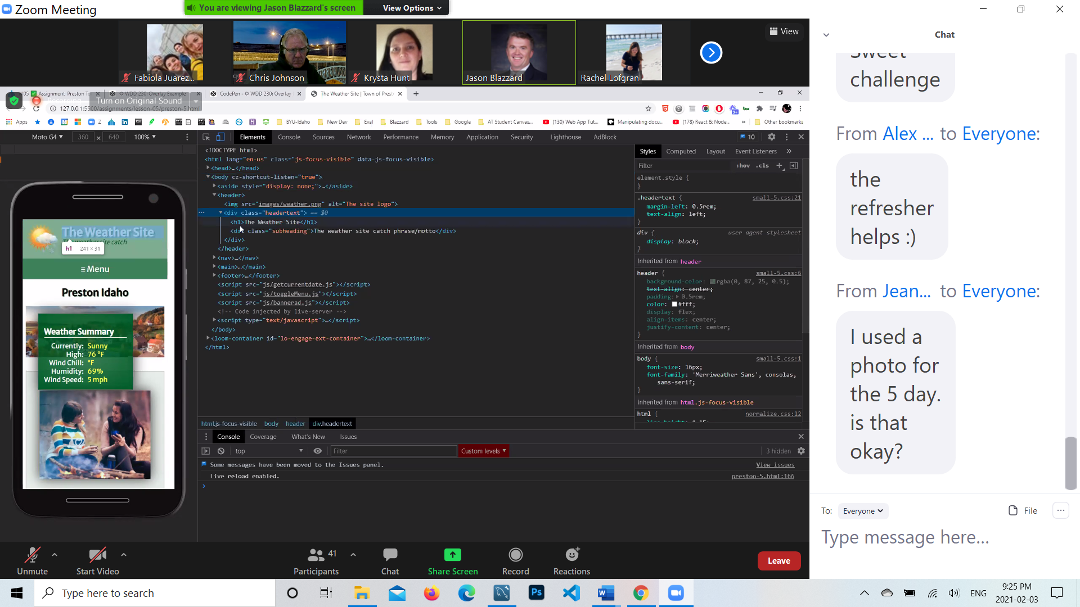

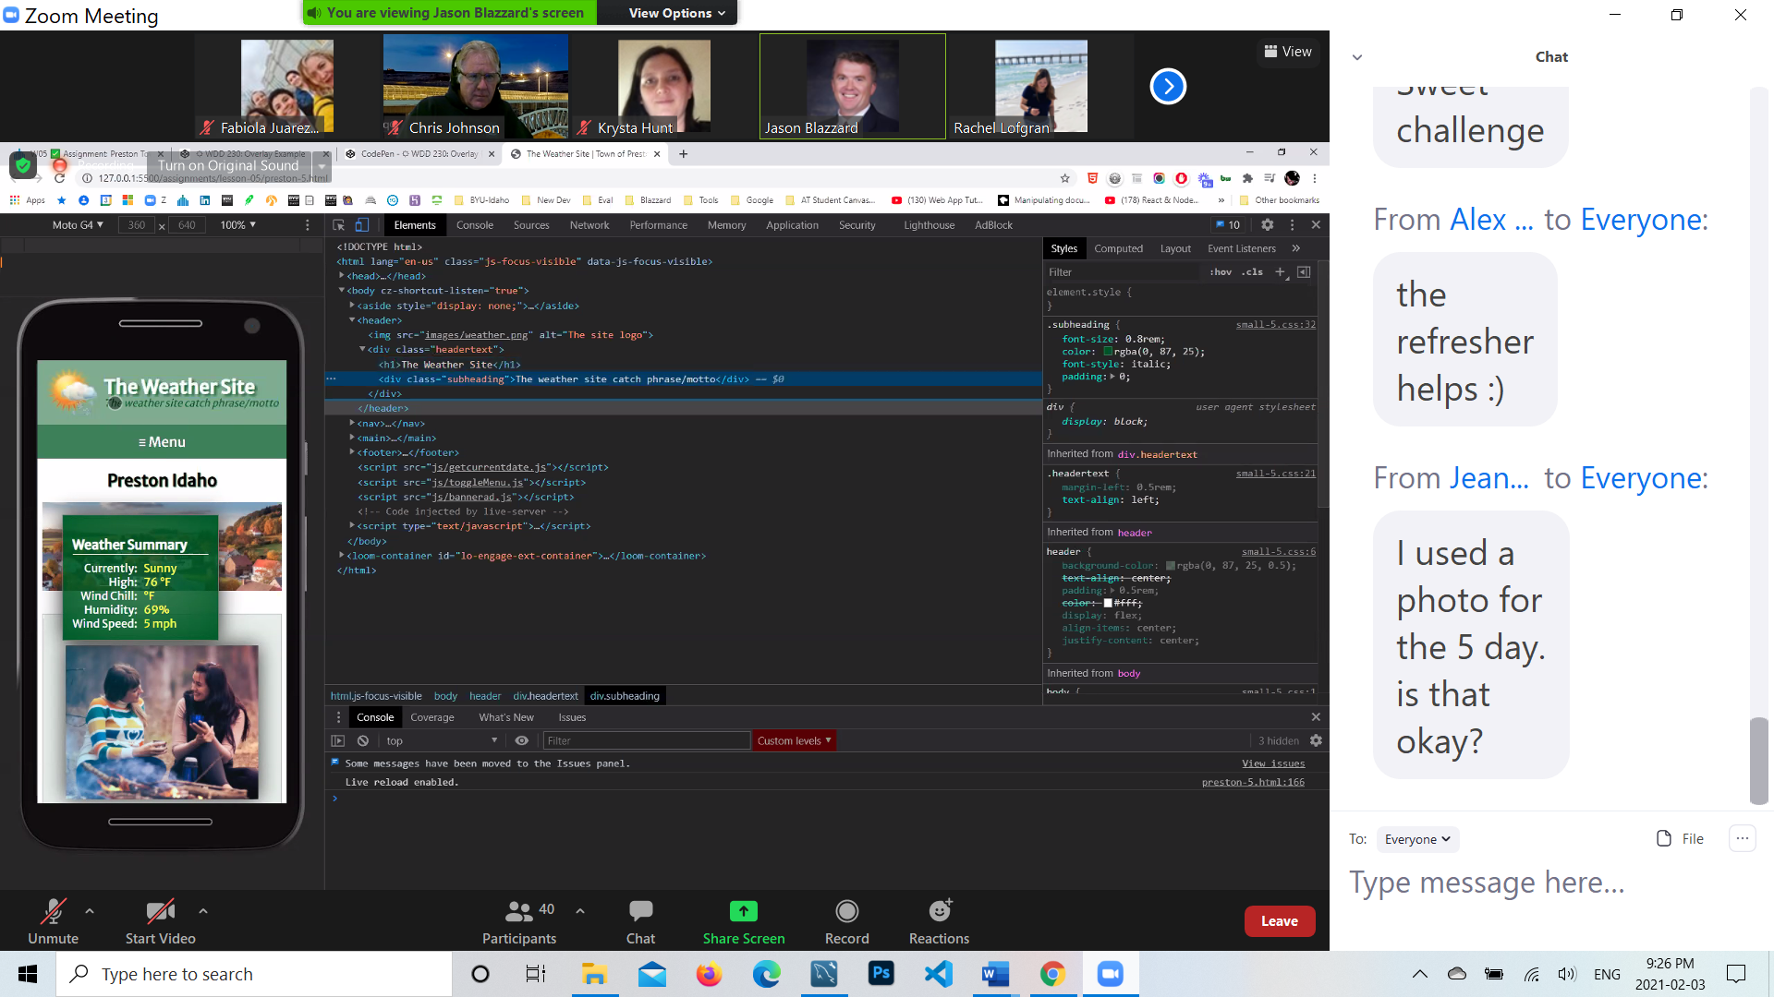

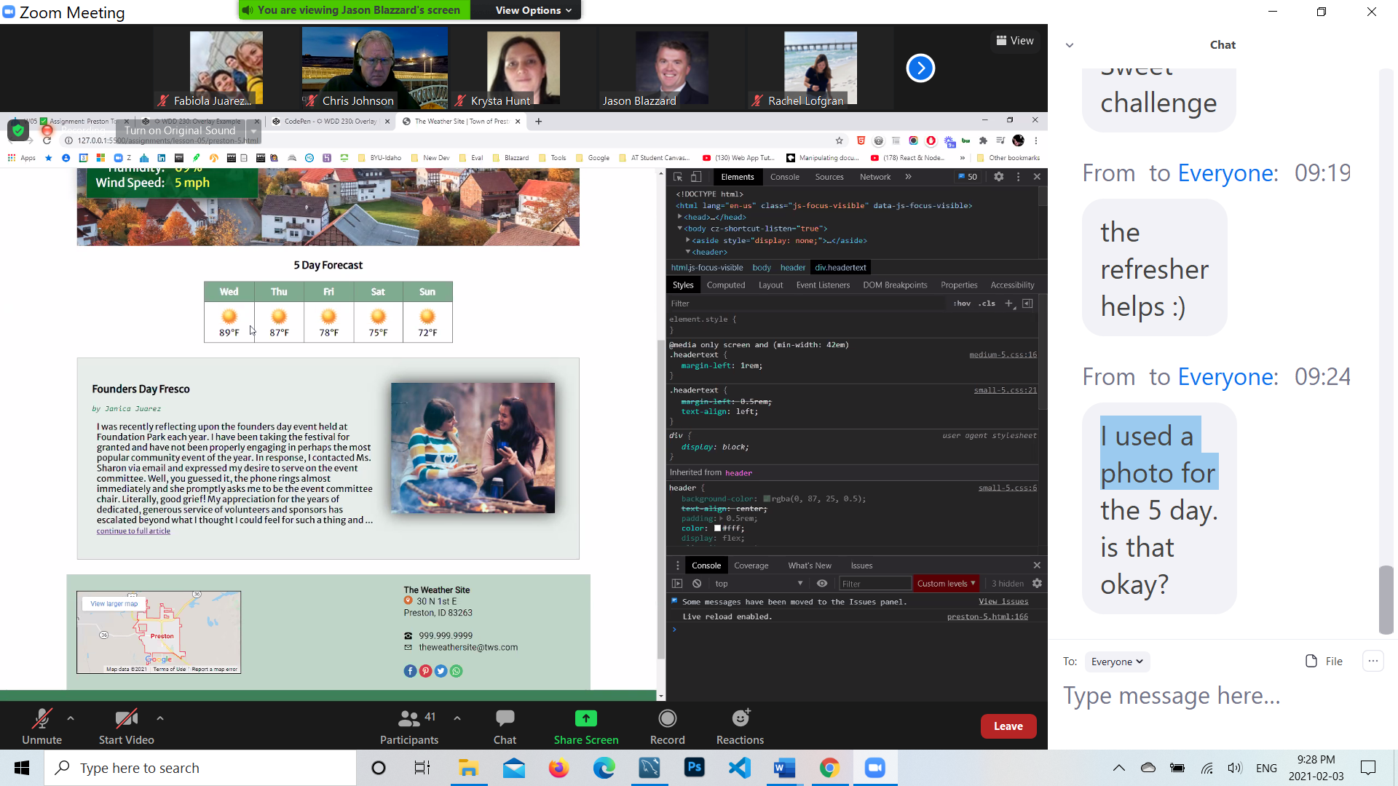

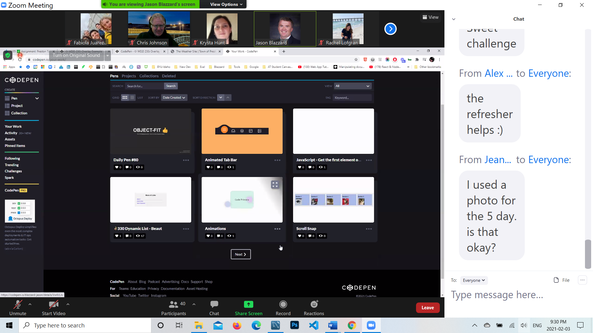

[**https://codepen.io/blazzard-jason/pen/gJeEay**](https://codepen.io/blazzard-jason/pen/gJeEay)

**HML**

**<h1>Display Data: <span class="tomato">Table <span class="tiny">vs</span> Flex <span class="tiny">vs</span> Column <span class="tiny">vs</span> Grid</span></h1>**

**<h2>Table</h2>**

**<table>**

**<thead>**

**<tr>**

**<th>1</th>**

**<th>2</th>**

**<th>3</th>**

**<th>4</th>**

**<th>5</th>**

**<th>6</th>**

**</tr>**

**</thead>**

**<tbody>**

**<tr>**

**<td>**

**<img src="https://placekitten.com/50/50" alt="kitten!"><br> Kitten 1**

**</td>**

**<td>**

**<img src="https://placekitten.com/50/50" alt="kitten!"><br> Kitten 2 </td>**

**<td>**

**<img src="https://placekitten.com/50/50" alt="kitten!"><br> Kitten 3 </td>**

**<td>**

**<img src="https://placekitten.com/50/50" alt="kitten!"><br> Kitten 4**

**</td>**

**<td>**

**<img src="https://placekitten.com/50/50" alt="kitten!"><br> Kitten 5**

**</td>**

**<td>**

**<img src="https://placekitten.com/50/50" alt="kitten!"><br> Kitten 6**

**</td>**

**</tr>**

**</tbody>**

**</table>**

**<h2>Flex</h2>**

**<div class="flex">**

**<div class="flex-col">**

**<span class="col-head">1</span>**

**<img src="https://placekitten.com/50/50" alt="kitten!">**

**<span class="data">Kitten 1</span>**

**</div>**

**<div class="flex-col">**

**<span class="col-head">2</span>**

**<img src="https://placekitten.com/50/50" alt="kitten!">**

**<span class="data">Kitten 2</span>**

**</div>**

**<div class="flex-col">**

**<span class="col-head">3</span>**

**<img src="https://placekitten.com/50/50" alt="kitten!">**

**<span class="data">Kitten 3</span>**

**</div>**

**<div class="flex-col">**

**<span class="col-head">4</span>**

**<img src="https://placekitten.com/50/50" alt="kitten!">**

**<span class="data">Kitten 4</span>**

**</div>**

**<div class="flex-col">**

**<span class="col-head">5</span>**

**<img src="https://placekitten.com/50/50" alt="kitten!">**

**<span class="data">Kitten 5</span>**

**</div>**

**<div class="flex-col">**

**<span class="col-head">6</span>**

**<img src="https://placekitten.com/50/50" alt="kitten!">**

**<span class="data">Kitten 6</span>**

**</div>**

**</div>**

**<h2>Columns</h2>**

**<div class="column">**

**<div class="column-col">**

**<span class="col-head">1</span>**

**<img src="https://placekitten.com/50/50" alt="kitten!">**

**<span class="data">Kitten 1</span>**

**</div>**

**<div class="column-col">**

**<span class="col-head">2</span>**

**<img src="https://placekitten.com/50/50" alt="kitten!">**

**<span class="data">Kitten 2</span>**

**</div>**

**<div class="column-col">**

**<span class="col-head">3</span>**

**<img src="https://placekitten.com/50/50" alt="kitten!">**

**<span class="data">Kitten 3</span>**

**</div>**

**<div class="column-col">**

**<span class="col-head">4</span>**

**<img src="https://placekitten.com/50/50" alt="kitten!">**

**<span class="data">Kitten 4</span>**

**</div>**

**<div class="column-col">**

**<span class="col-head">5</span>**

**<img src="https://placekitten.com/50/50" alt="kitten!">**

**<span class="data">Kitten 5</span>**

**</div>**

**<div class="column-col">**

**<span class="col-head">6</span>**

**<img src="https://placekitten.com/50/50" alt="kitten!">**

**<span class="data">Kitten 6</span>**

**</div>**

**</div>**

**<h2>Grid</h2>**

**<div class="grid">**

**<div class="grid-col">**

**<span class="col-head">1</span>**

**<img src="https://placekitten.com/50/50" alt="kitten!">**

**<span class="data">Kitten 1</span>**

**</div>**

**<div class="grid-col">**

**<span class="col-head">2</span>**

**<img src="https://placekitten.com/50/50" alt="kitten!">**

**<span class="data">Kitten 2</span>**

**</div>**

**<div class="grid-col">**

**<span class="col-head">3</span>**

**<img src="https://placekitten.com/50/50" alt="kitten!">**

**<span class="data">Kitten 3</span>**

**</div>**

**<div class="grid-col">**

**<span class="col-head">4</span>**

**<img src="https://placekitten.com/50/50" alt="kitten!">**

**<span class="data">Kitten 4</span>**

**</div>**

**<div class="grid-col">**

**<span class="col-head">5</span>**

**<img src="http://placekitten.com/50/50" alt="kitten!">**

**<span class="data">Kitten 5</span>**

**</div>**

**<div class="grid-col">**

**<span class="col-head">6</span>**

**<img src="https://placekitten.com/50/50" alt="kitten!">**

**<span class="data">Kitten 6</span>**

**</div>**

**</div>**

**CSS**

**@import url("https://fonts.googleapis.com/css?family=Acme&display=swap");**

**body {**

**max-width: 640px;**

**margin: 0 auto;**

**padding: 5px;**

**}**

**h1 {**

**font-size: 1.5em;**

**border-bottom: 1px solid #abe;**

**font-family: Acme, Arial, sans-serif;**

**}**

**h2 {**

**font-size: 1em;**

**color: tomato;**

**font-family: Acme, Arial, sans-serif;**

**margin-left: 10px;**

**}**

**.tiny {**

**font-size: .8rem;**

**}**

**.tomato {**

**color: tomato;**

**}**

**.flex {**

**display: flex;**

**/* flex-direction: row; */**

**/* let us combine row and wrap with flow */**

**flex-flow: row wrap;**

**}**

**.flex-col {**

**flex: 1 1 auto;**

**background-color: #bed;**

**}**

**.flex-col, .column-col, .grid-col {**

**border-bottom: 1px solid #333;**

**border-left: 1px solid #333;**

**text-align: center;**

**}**

**.flex-col:hover, td:hover, .column-col:hover, .grid-col:hover {**

**opacity: 0.75;**

**background-color: black;**

**color: white;**

**}**

**.flex, .column, .grid {**

**border-right: 1px solid #333;**

**}**

**.col-head {**

**display: block;**

**padding: 5px;**

**border-bottom: 1px solid #333;**

**text-align: center;**

**}**

**img {**

**border-radius: 100px;**

**padding: 0.25rem;**

**}**

**.data {**

**display: block;**

**padding: 0 5px 5px;**

**font-size: 0.8rem;**

**text-align: center;**

**}**

**.col-head,th {**

**font-weight: 700;**

**font-size: 1rem;**

**background-color: black;**

**color: white;**

**}**

**/* Table styling and layout with no extras*/**

**table,th,td {**

**border: 1px solid #333;**

**border-collapse: collapse;**

**padding: 5px;**

**}**

**td {**

**background-color: #bad;**

**font-size: 0.8rem;**

**text-align: center;**

**}**

**/* Column styling and layout */**

**.column {**

**column-count: 6;**

**column-gap: 0;**

**}**

**.column img {**

**width: 50%;**

**}**

**.column-col {**

**background-color: #abe;**

**}**

**/* Grid */**

**.grid {**

**display: grid;**

**grid-template-columns: repeat(auto-fit, minmax(50px,1fr));**

**}**

**.grid-col {**

**background-color: tomato;**

**}**

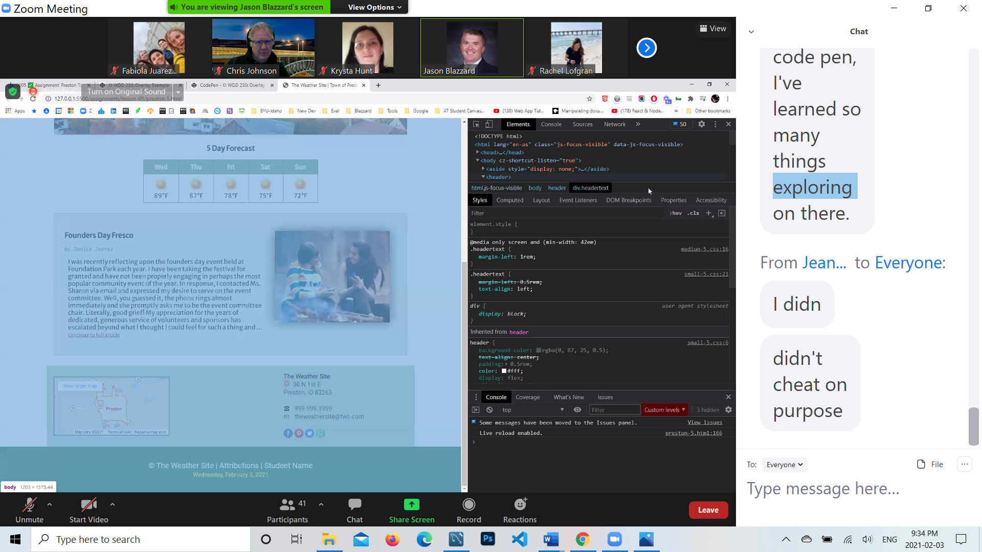

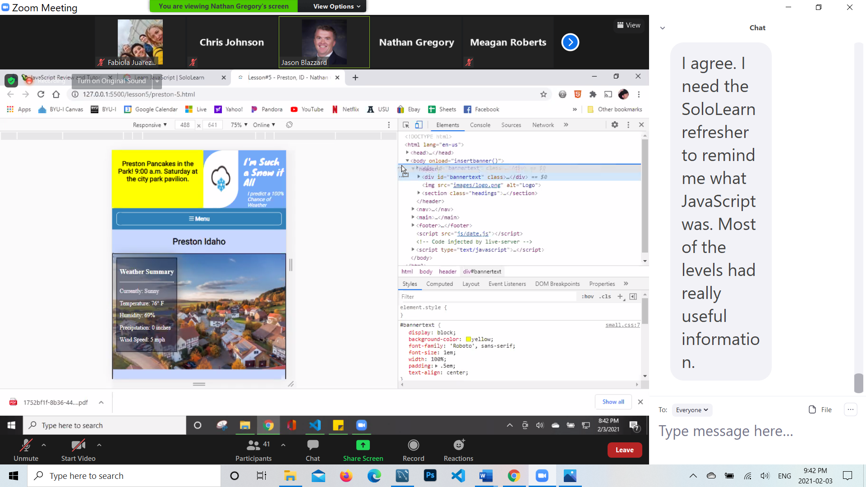

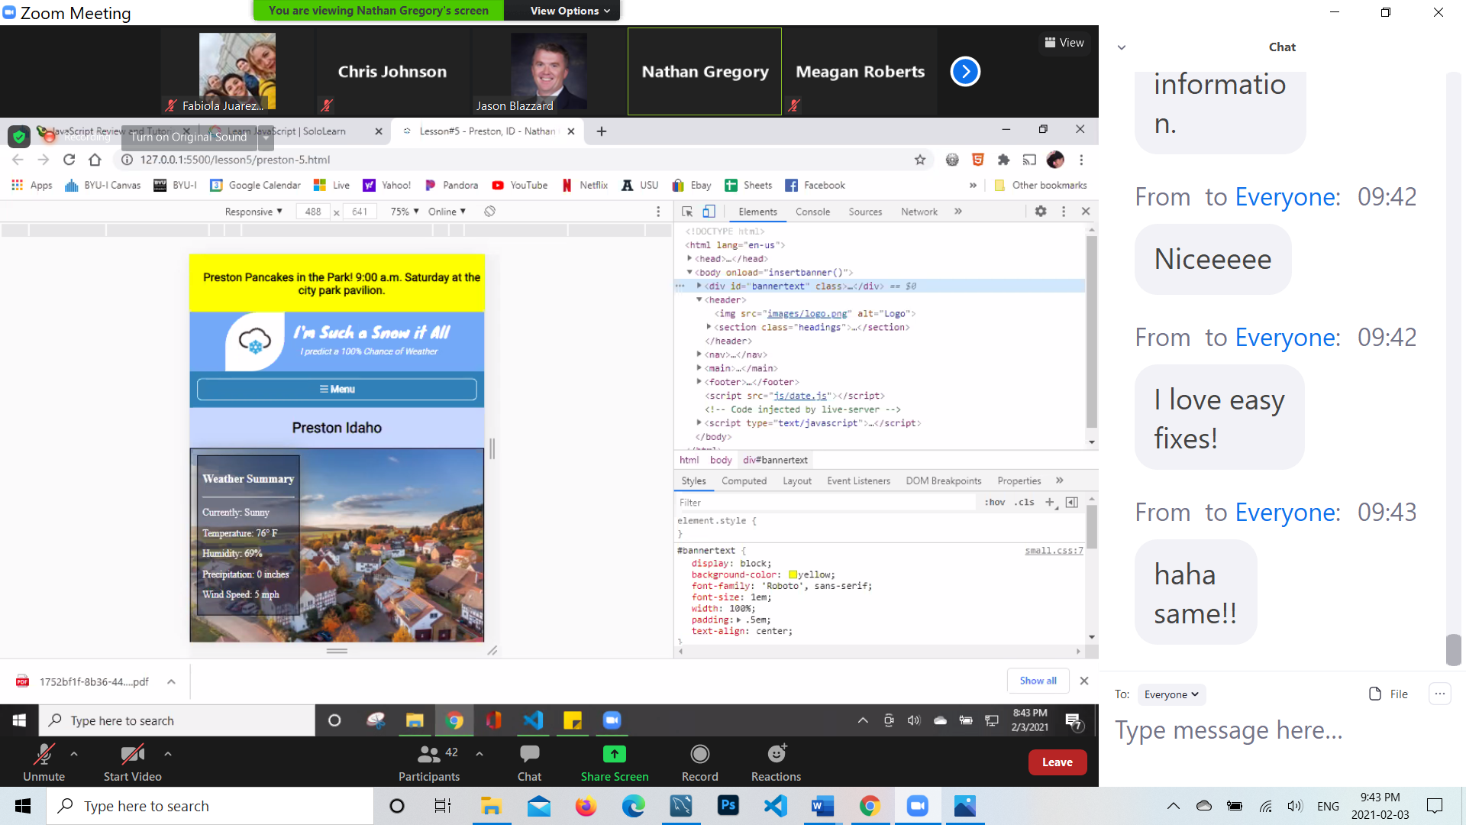

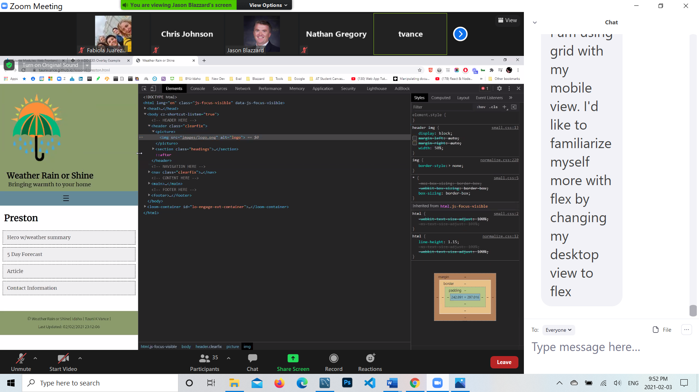

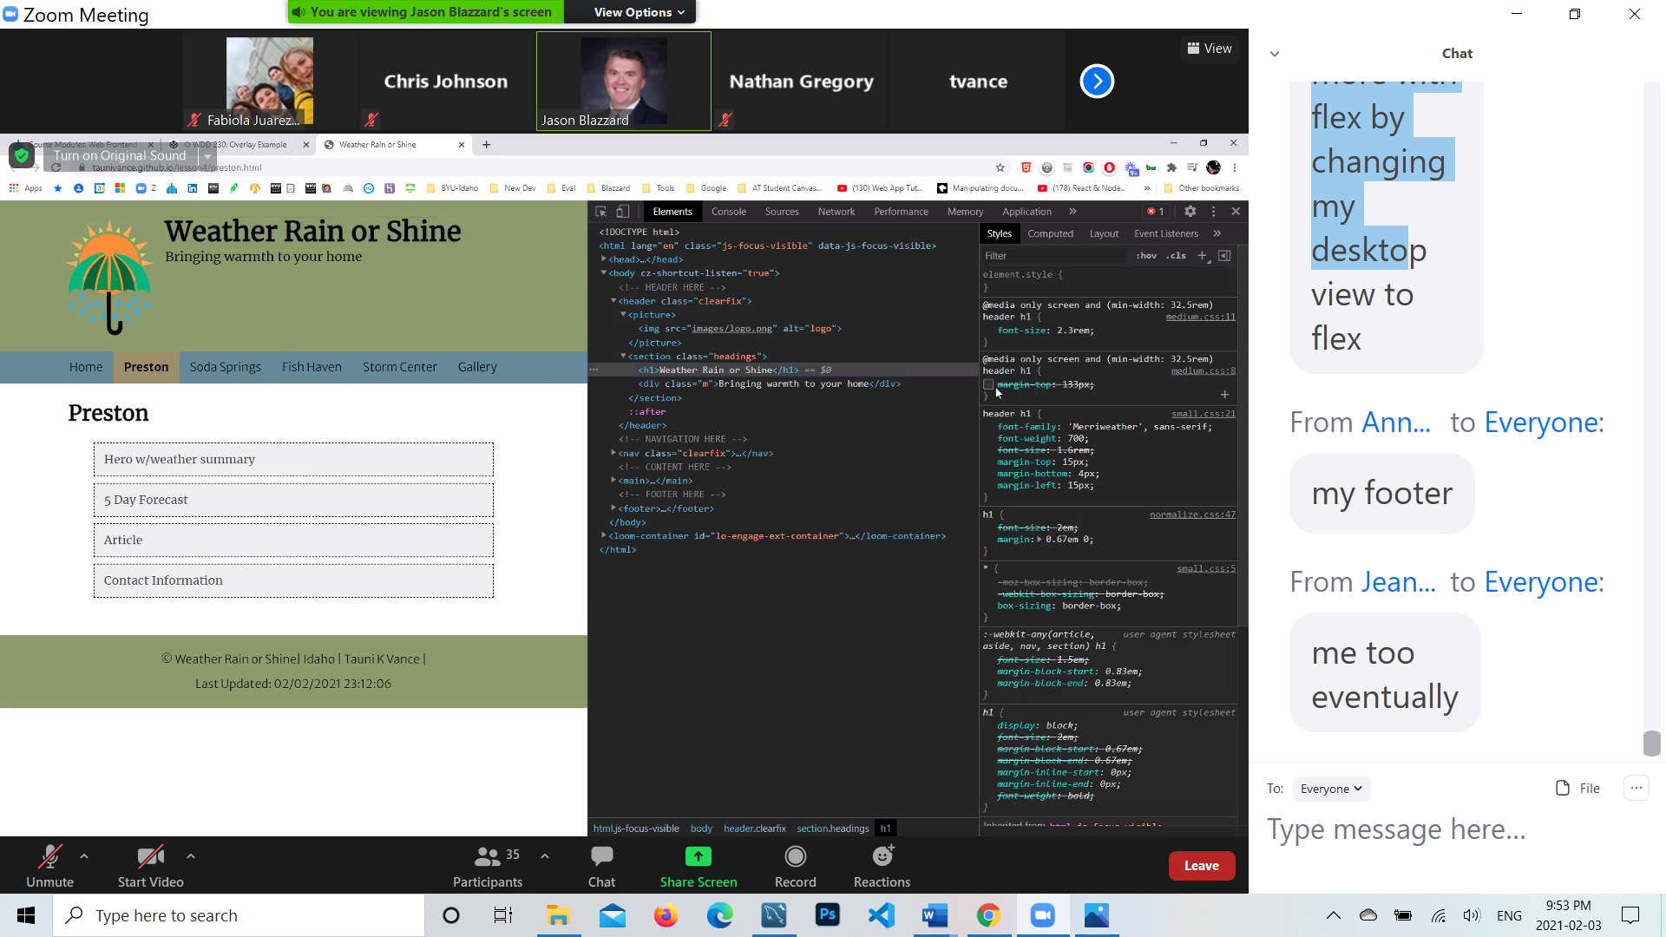

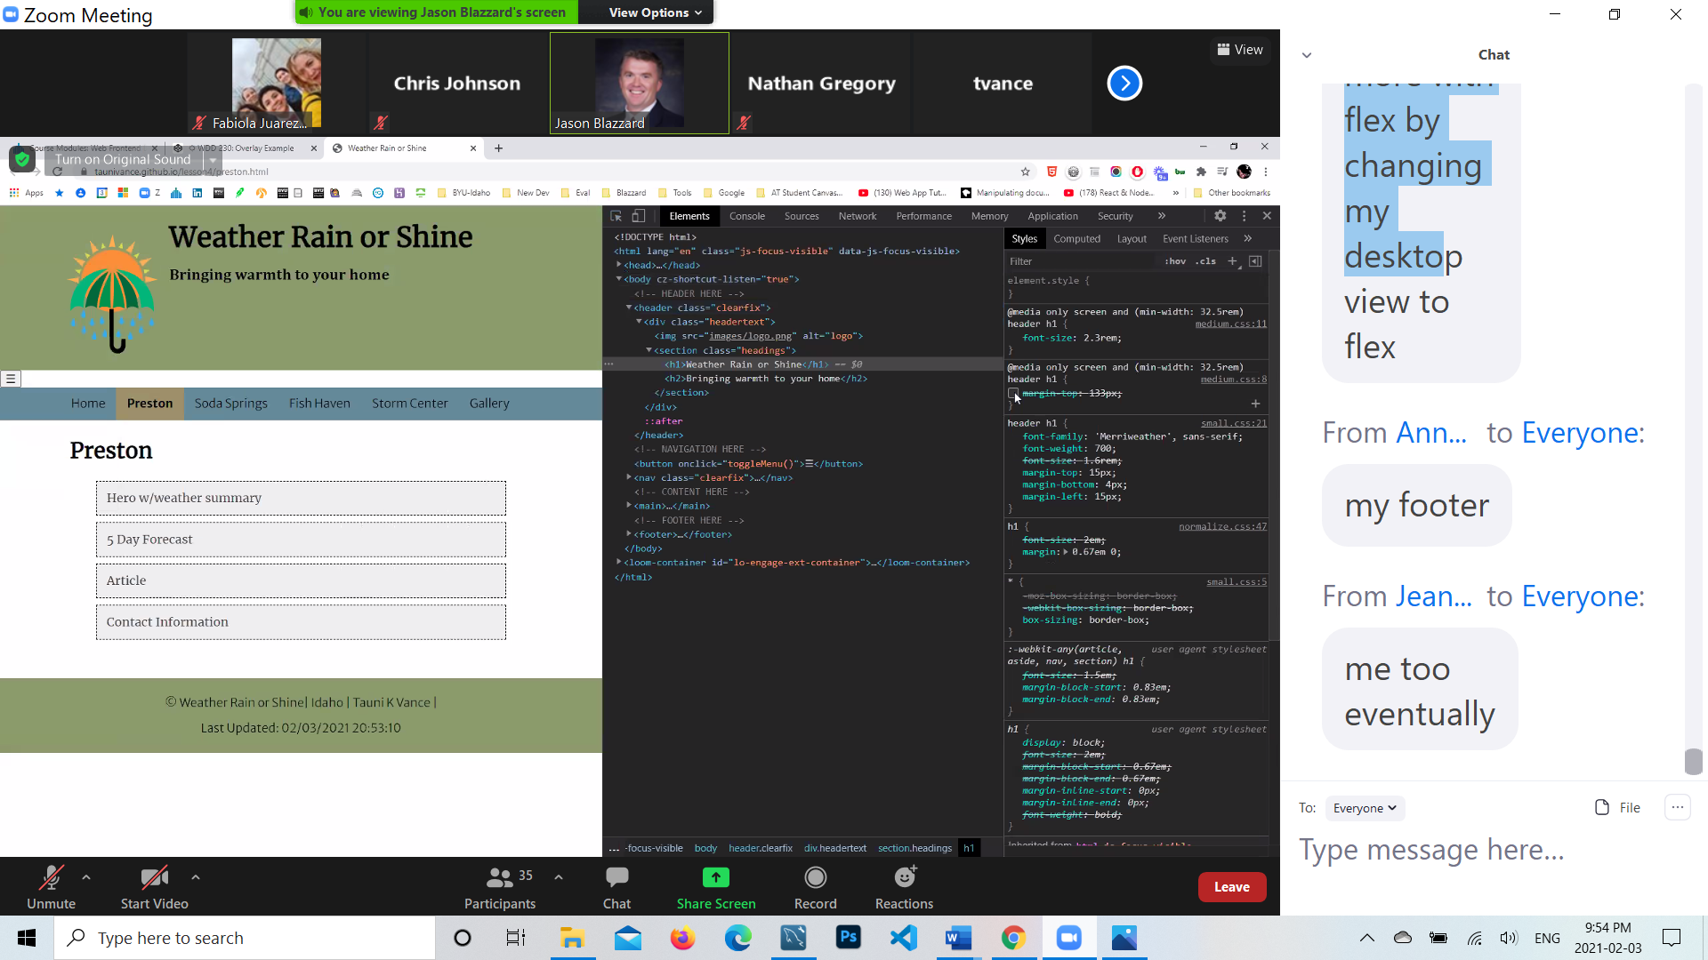

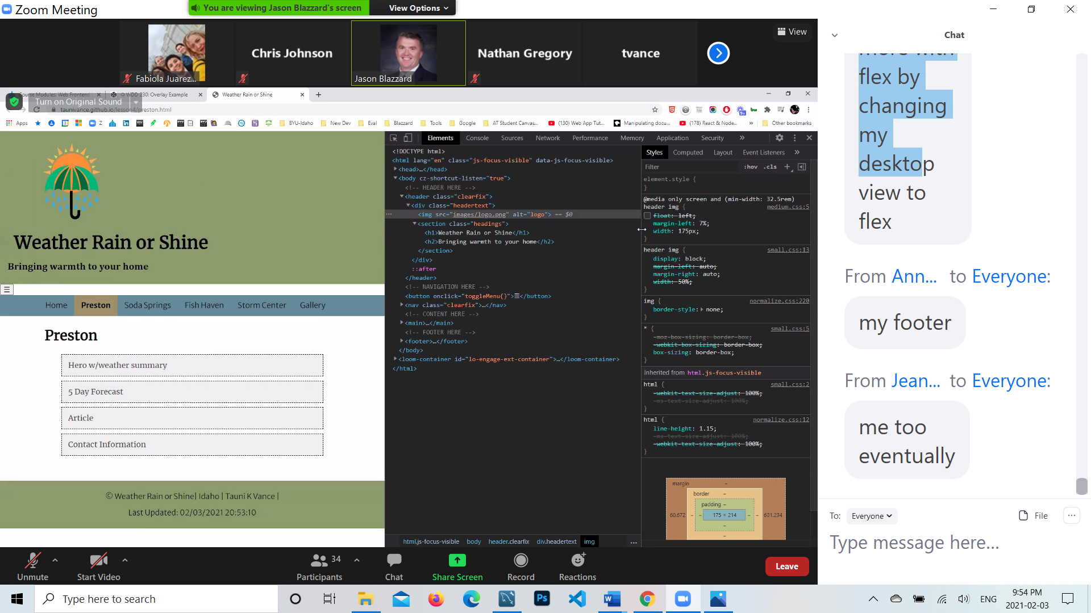



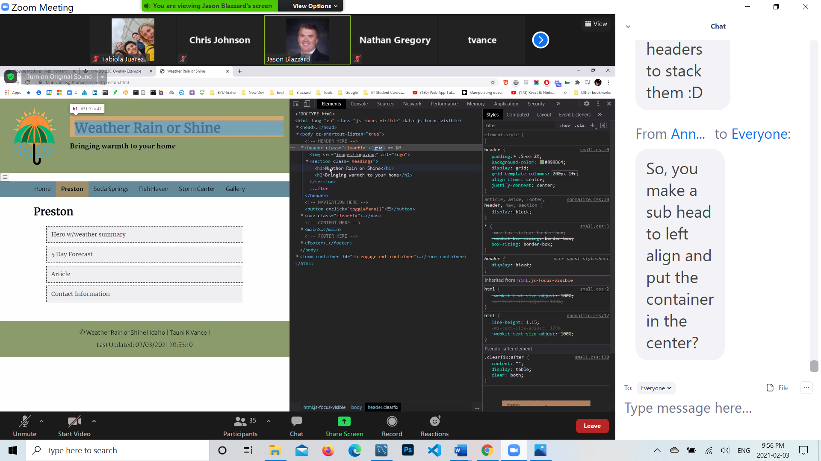

**Correct**

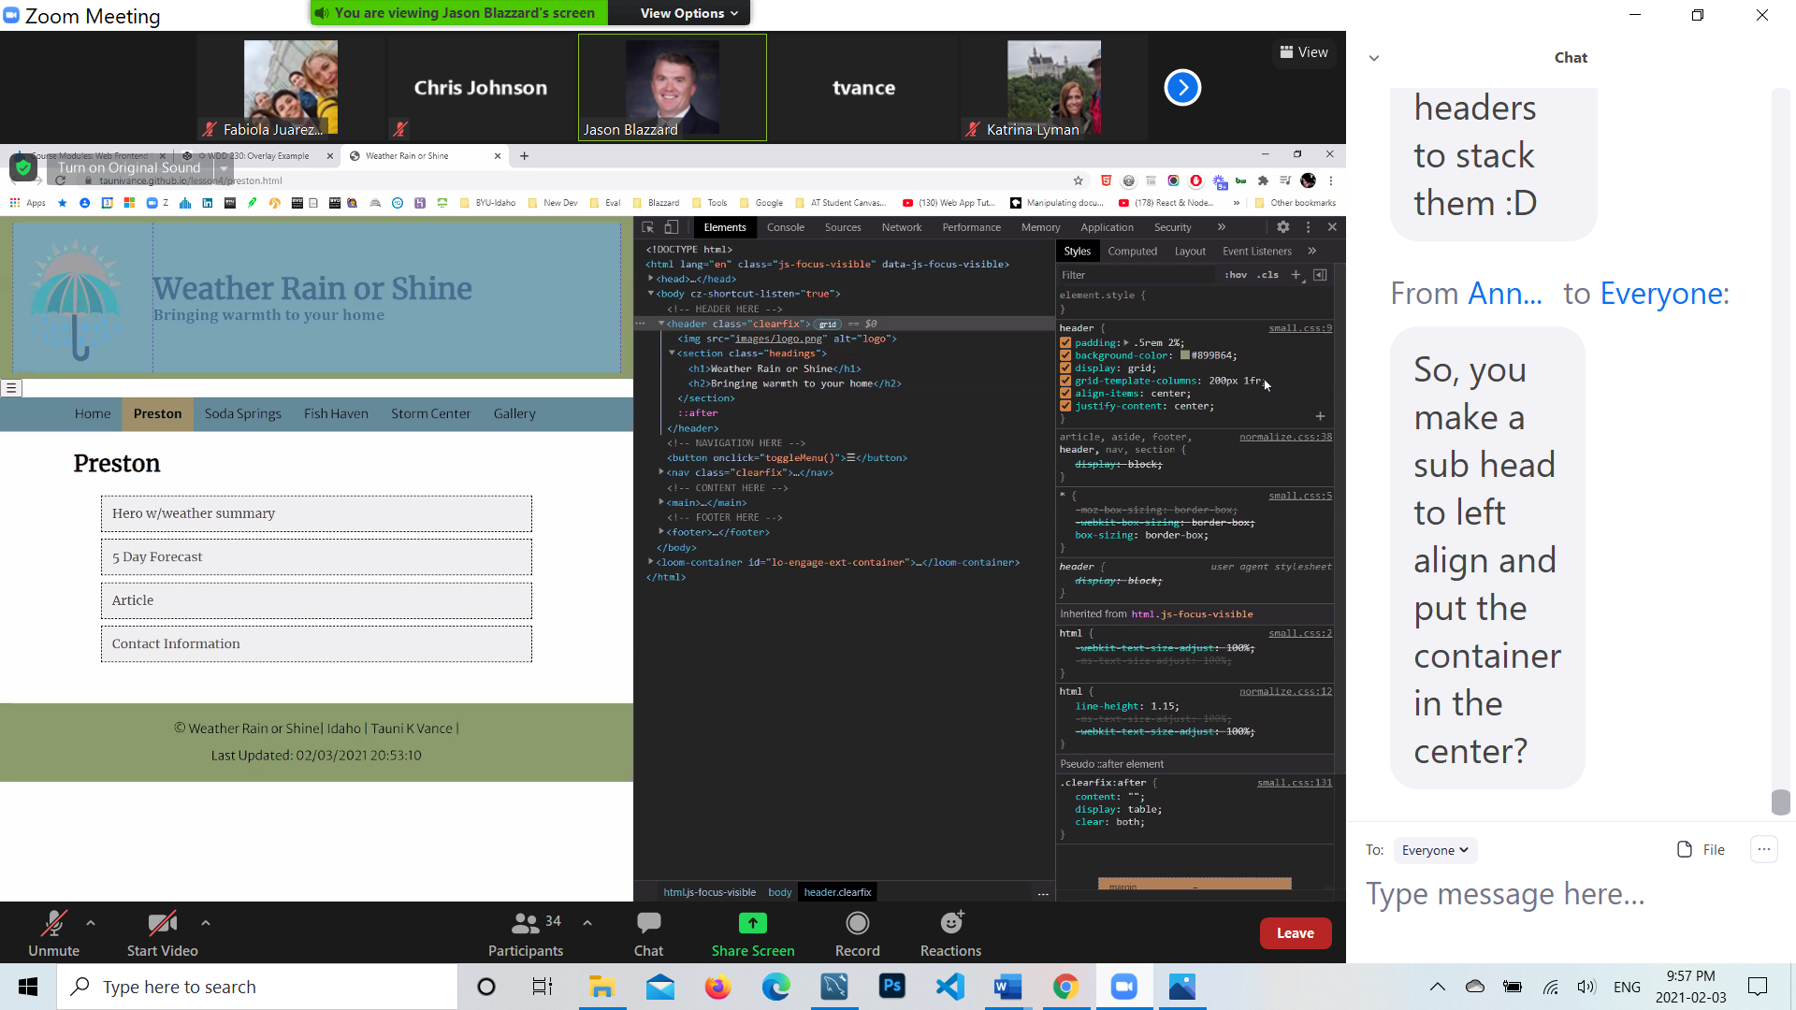

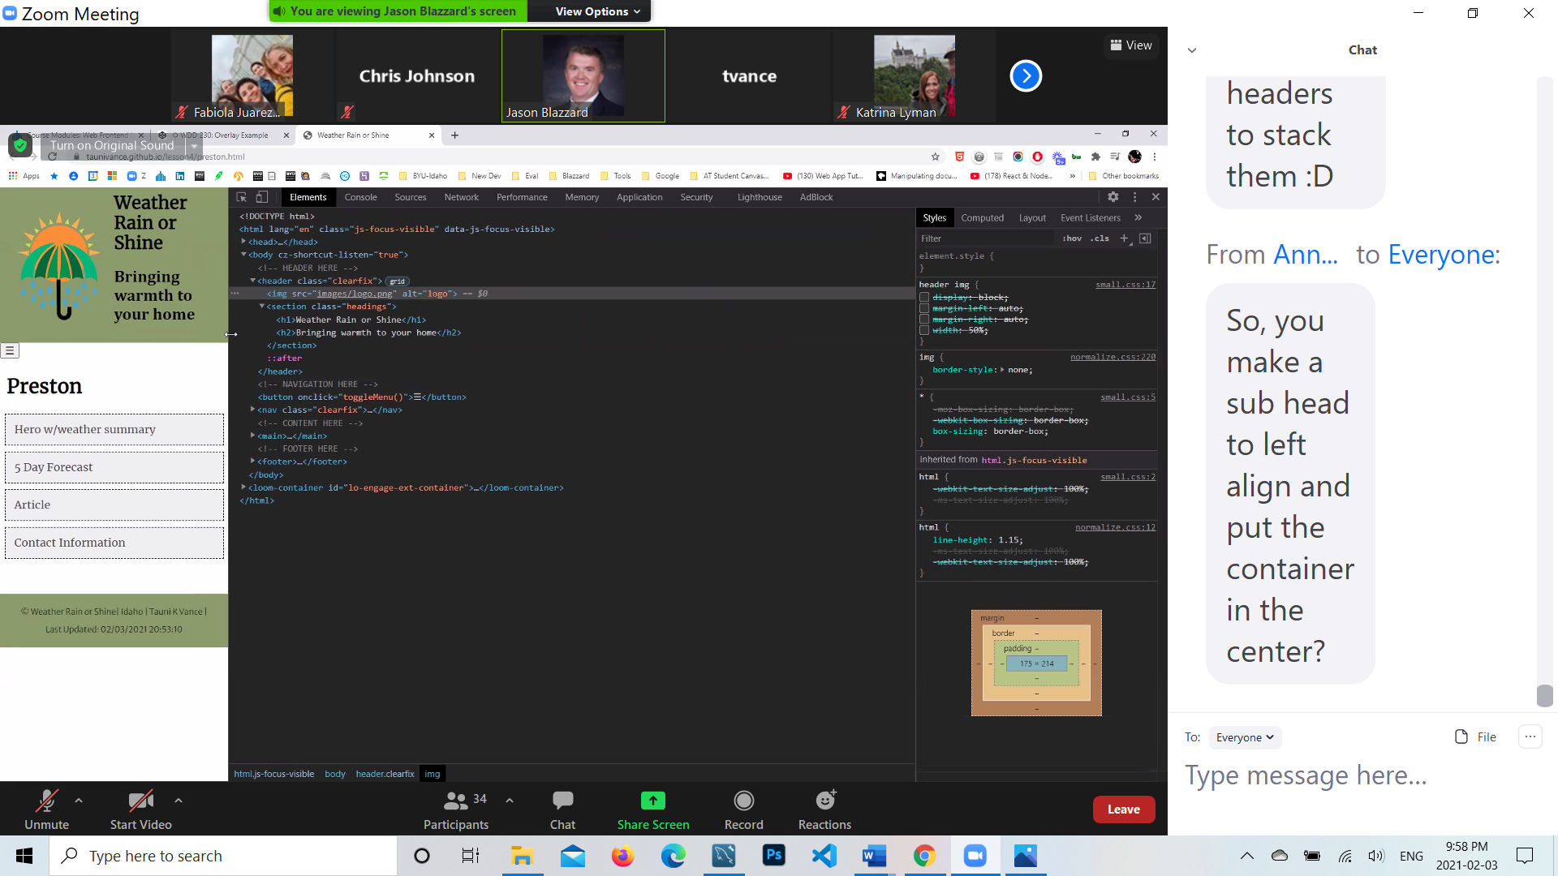

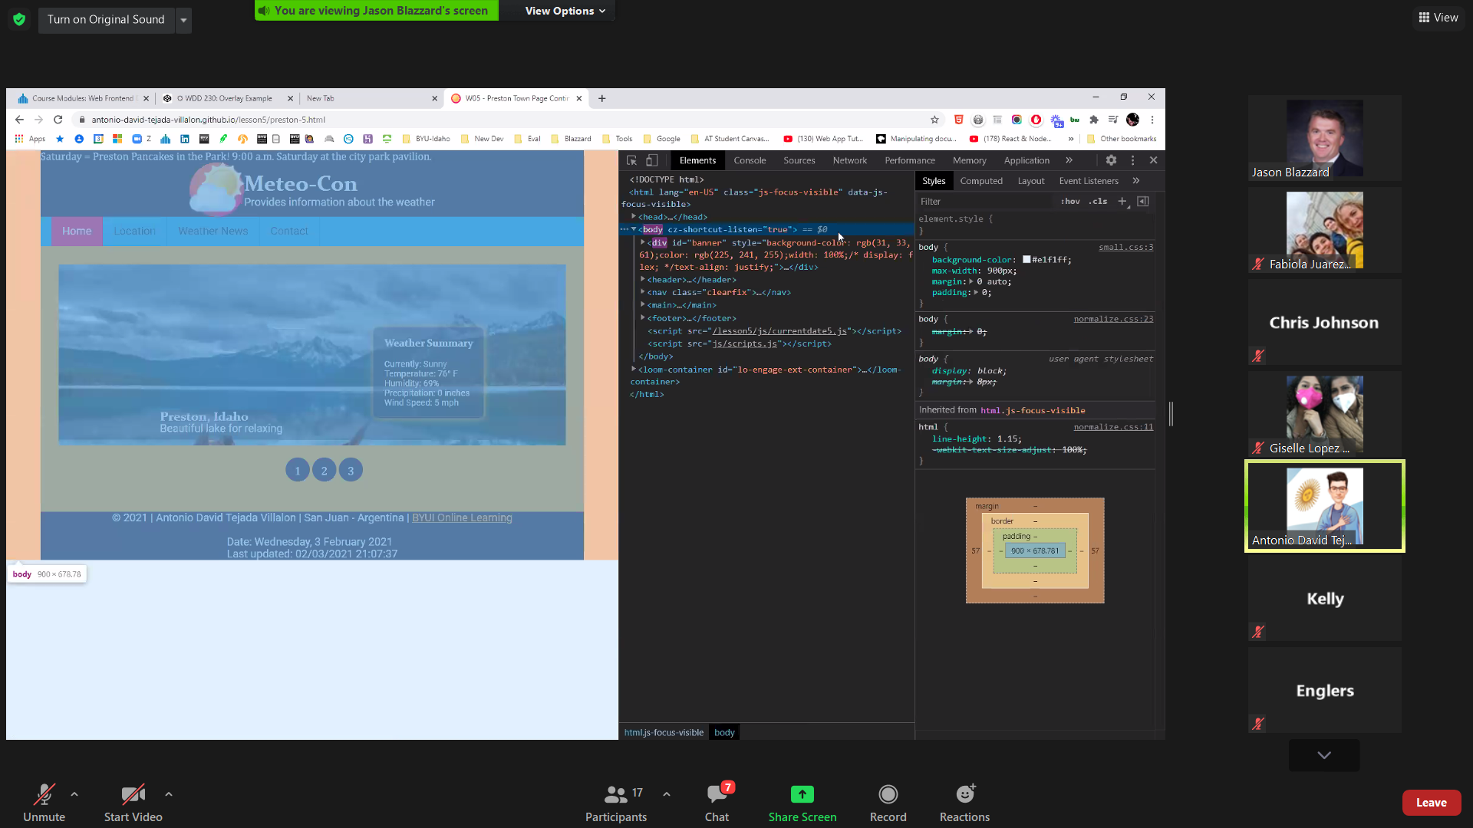

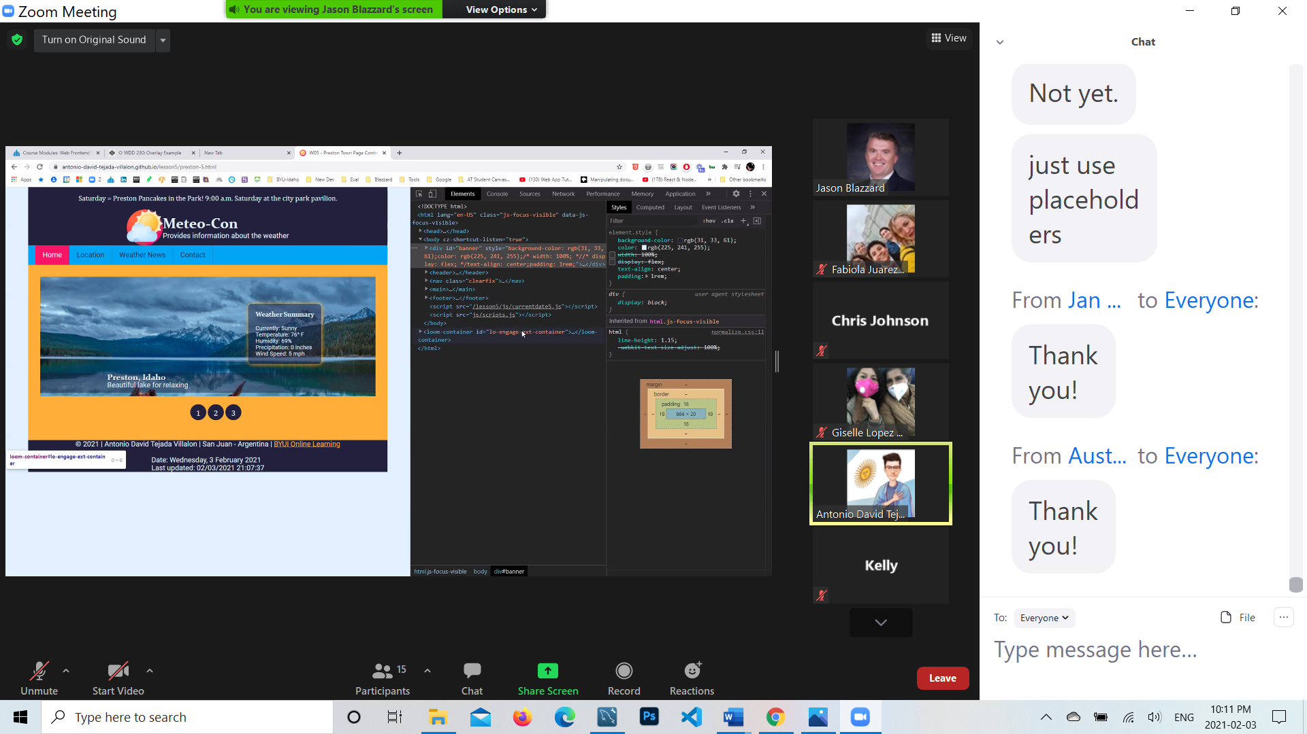

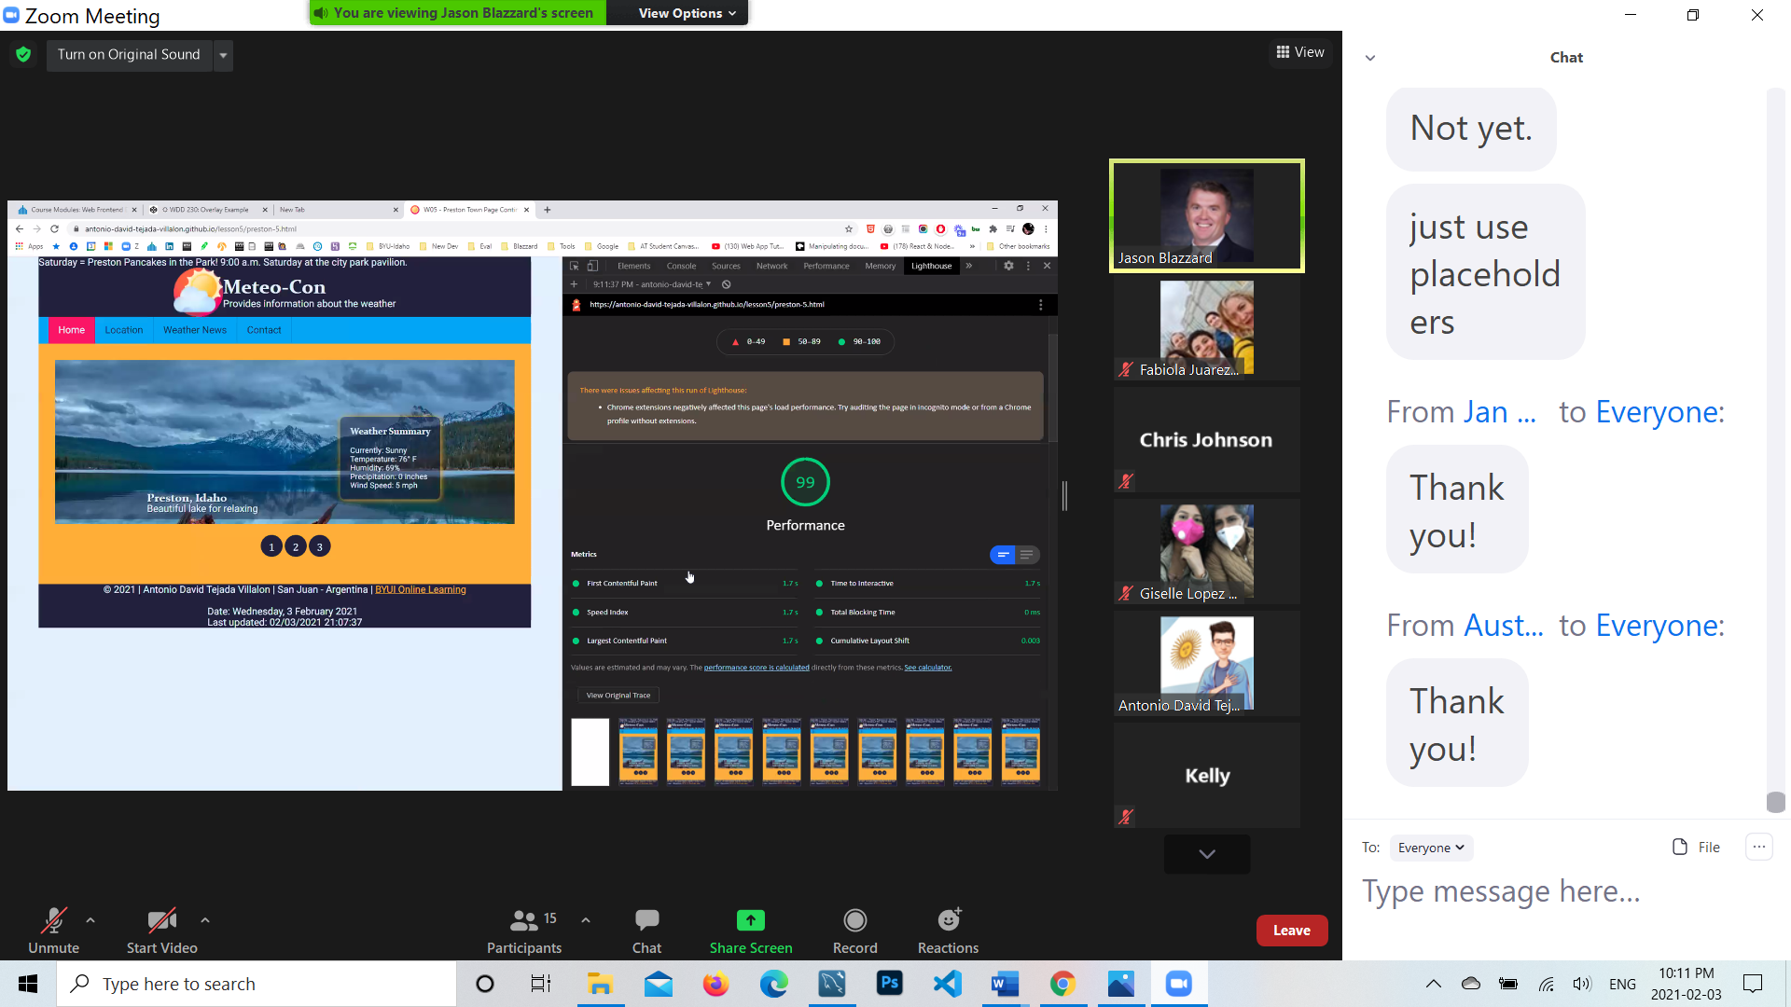

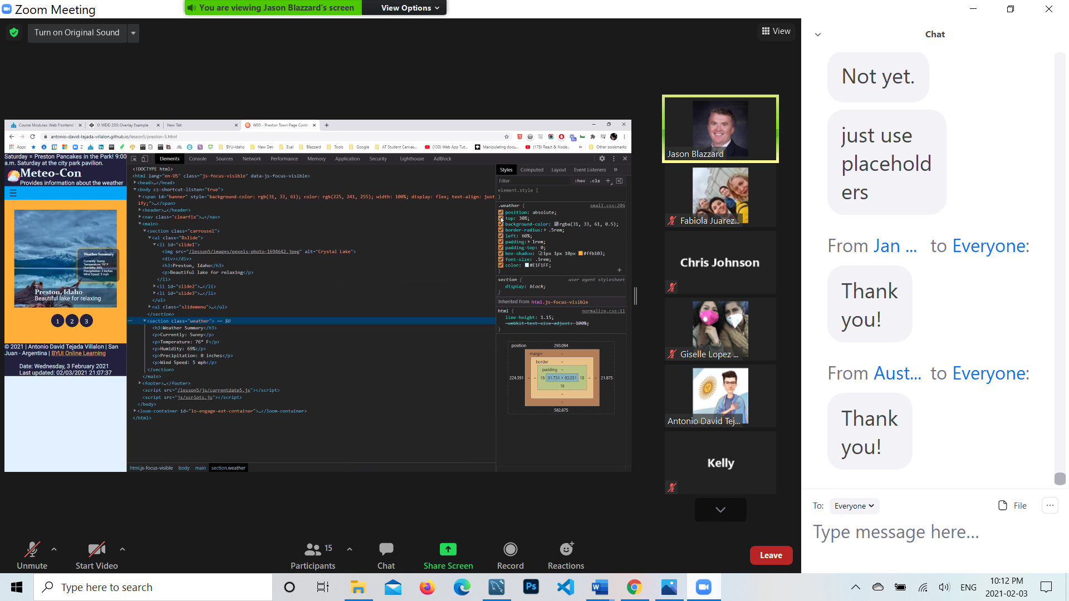

**blazzardj@byui.edu**